
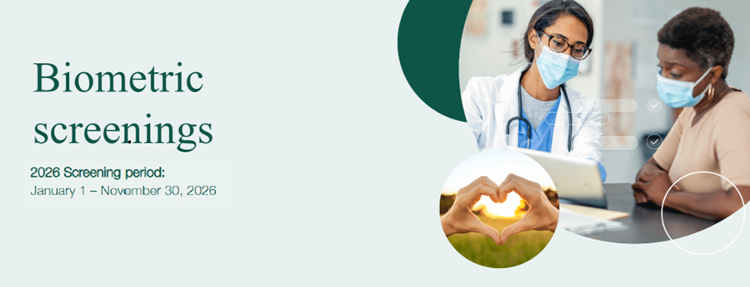

How to Schedule a Screening at a
Quest Diagnostics Patient Service Center
or
an SHBP-Sponsored Onsite Screening Event

- If you have not registered for the BeWell SHBP® program, register here.
- If you have already registered for the BeWell SHBP® program, you can log in here.
- Once logged into your Sharecare account, click on the “Achieve”button. It will display on the top of the page in the web browser version, and bottom of the page in the mobile app..
- Click on the “Programs” tile.
- Click on the “Biometric Screening” tile. This will redirect you to the Quest scheduler.
- Read the Terms and Conditions and click “Accept & Continue”.
- Read the consent language, click on “I accept” then click the “Continue” box.
- Confirm your personal information and mailing address is correct and click “Save”.
- To schedule a screening at a Patient Service Center (PSC) click on “Schedule a Screening” or to schedule a screening at an onsite event click on “Make an Appointment”.
- Search for and select a desired location.
- Choose desired date and time.
- Review and confirm all information.

NOTE: Your biometric screening at a Quest Diagnostics PSC or an SHBP-sponsored onsite screening event must be scheduled through your Sharecare account (instructions above). If these biometrics screenings are not scheduled through your Sharecare account, you may be responsible for 100% of the cost.

