How to Schedule a Screening at a
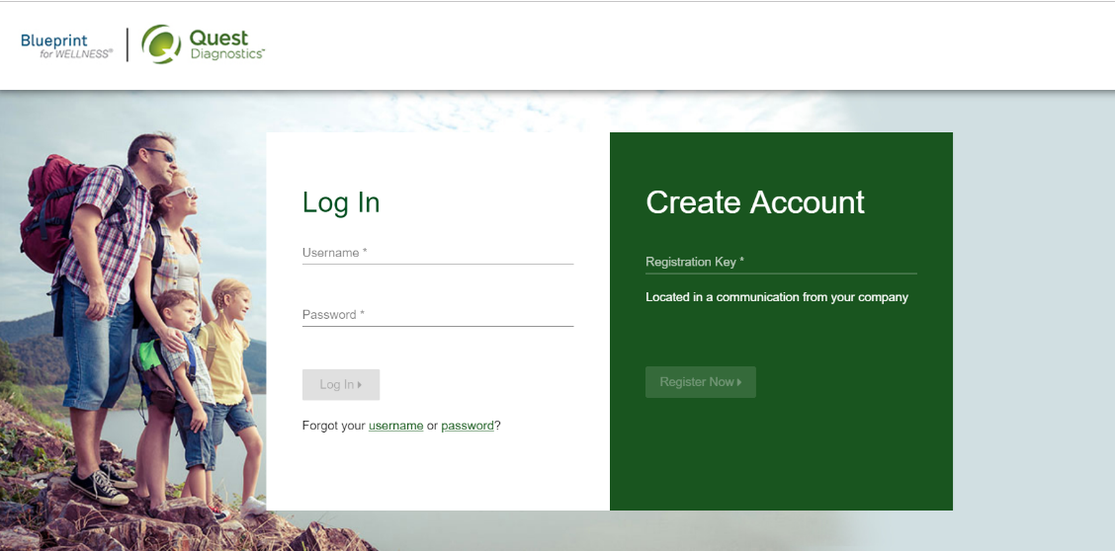
Quest Patient Service Center

- If you have not registered for the Be Well SHBP program, register here
- If you have already registered to the Be Well SHBP program, you can log in here
- Once logged into your Sharecare account, click on the “Achieve” link on the left-hand side
- Click on the “Programs” tile
- Click on the “Health Screening” tile. This will redirect you to the Quest scheduler
- Read the Terms and Conditions and click “Accept & Continue”
- Read the consent language, click on “I accept” then click the “Continue” box
- Confirm personal information and mailing address is correct and click “Save”
- To schedule at a Patient Service Center (PSC) click on “Schedule a Screening”
- Search for and select desired location
- Choose desired date & time
- Review and confirm information

